At school, you will need to sign on to the chrome books/google accounts using your AHS sign in…

FOR FRESHMEN AND NEW STUDENTS:

USERNAME ASD######@asd.wednet.edu

PASSWORD: ASDbirthdate (case sensitive—capitals matter)

FOR EVERYONE ELSE:

USERNAME AHS######@asd.wednet.edu

PASSWORD: CAPITAL LETTERS (first initial) (last initial)birthdate (case sensitive—capitals matter Alice Smithson would be AS111900)

At home, you can go directly to google classroom using the link below; however, the username and password are the same and EITHER way works to access the classroom.

Open a browser, then

Go to http://classroom.google.com/
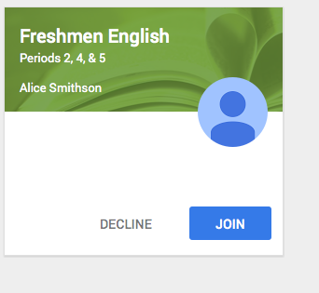
You then should see a box that looks like this…

click the join button

Go through the tour, so you know what is available in classroom.

As people join the class, you will be able to see a list of all the students in my three Freshmen English classes. This will allow you to post questions about assignments, etc. However, only those invited by me will be able to access the class and the list.

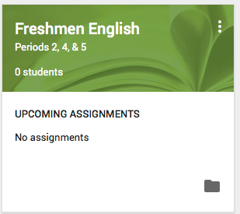
I will be posting assignments, notes, anything that I think might be useful to you and help you be successful in this class; however, this DOES NOT TAKE THE PLACE OF YOUR PLANNER. This is a resource that I will keep updated as I have time. This is a new resource, so I am PLAYING with it, so let me know what you think; however, you will be able to create and submit assignments from the classroom.

You will have a box that looks like this: you will be able to go to google drive by clicking on the file folder in the lower right hand corner…you will create your assignment in google and eventually be able to submit it to me through classroom. That information will be coming…..

